Chiseldon Parish Council

The Old Chapel, Butts Road, Chiseldon, Wilts SN4 0NW
 01793 740744
email: clerk@chiseldon-pc.gov.uk
Facebook page: Chiseldon Parish Council Notices
Website: www.chiseldon-pc.gov.uk

Planning, Transport Development & Highways meeting Additional information 23.6.2020

Item 11. Draycot Foliat solar lighting.

Prolectric:
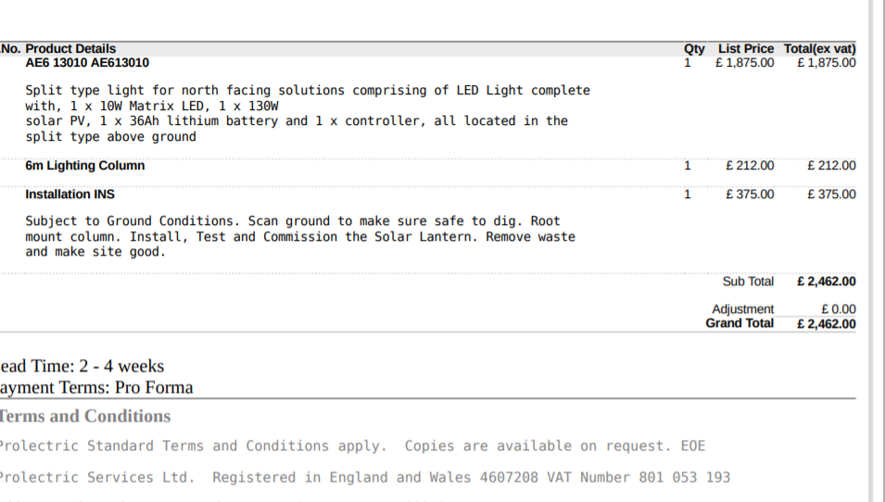

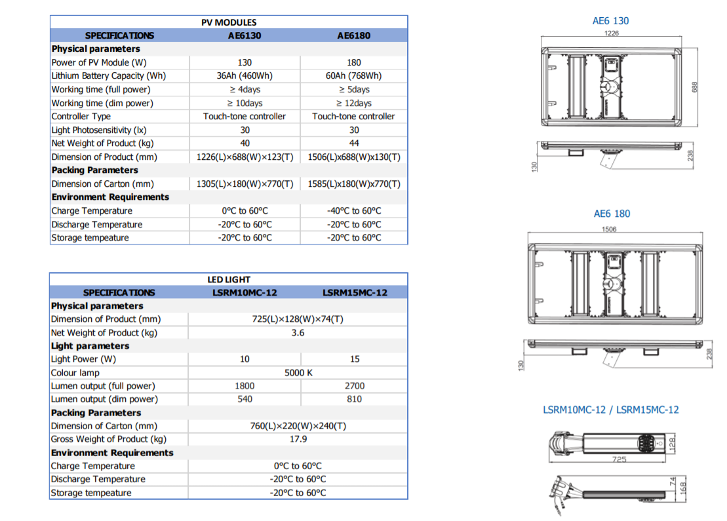
As mentioned this will give you excellent light when needed for manoeuvring vehicles in and out, while giving safety lighting for the duration of walking to and from your cars.
The light itself works on an ambient status of light output (30%) with PIR activation when needed taking the light to 100% output.
The above ambient light will be on from dusk for 8 hours. After 8 hours the LED turns off and will operate to 100% on PIR activation for the remainder of the night.

Note – SBC will need to give permission for this proposal before an order can be placed. This proposal will also need full council approval as no budgeted funds allocated in 2020/21 budget.

Item 12. Draycot Foliat Parking improvements for 2020/21.

Information from SBC Highways:

Approval for any schemes on the highway will be through the Highway Agreements team (highwayagreements@swindon.gov.uk). The Highway Agreements Manager (Steven Sanders) will be able to co-ordinate input from teams across Highways & Transport depending on the proposals for which you are seeking approval.
The use of a suitably experienced and qualified consultant (highway designer/engineer) is strongly advised as they will be aware of the various regulations and standards that apply to any highway schemes and they will be able to provide advice to the Parish before making an approach to the Council for approval.
Depending on the scale and type of scheme proposed typically the process could be -
• the consultant appointed by the town or parish submits preliminary designs, including any draft Traffic Regulation Orders and arranges an informal consultation process with stakeholders
• the consultant should modify his proposals in the light of the consultation exercise and resubmit them to the town/parish council and to us for technical design approval
• future ownership and maintenance arrangements – including funding would need to be agreed
• the town or parish may be required to obtain and submit to the council an independent Safety Audit for the scheme
• the consultant will need to undertake formal consultation and prepare any Traffic Regulation Orders the results of which will be submitted to the Council by the consultant and a decision made accordingly
• the town/parish council, consultant and council then agree how implementation is to proceed, with a suitably qualified and experienced contractor appointed
However the process and requirements will depend upon the scale and type of schemes put forward by the consultant on your behalf.
Note - The PC will need to use “Contract Finder” to get quotes for this work as per legal requirements as likely to be over £25,000.

Item 13. Preliminary Plans for Windmill Piece parking improvements for 2021/22.

To consider:
Length of layby to construct
Whether to start plans immediately or wait until Draycot Foliat plan is underway so the process is understood.
Will need to use Contract Finder to get quotes for this work as likely to be over £25,000.

Photos to show the area concerned: Site visit by Cllrs encouraged.

